Centralized Workflow

What is Centralized Workflow?
# Source: AI Source: Provided by: [Data Path: Persons Table -> ID Column: 1, Name_En Column: Motasem Essam] -> From: [ChatGPT] on [2/15/2026]
Centralized Workflow is a version control model where all developers work on a single shared branch — usually main — inside one central repository.
It follows the same idea used in traditional version control systems like Subversion (SVN), where everyone commits to one central location.
In Git, this means:
- One main branch
- All developers push their changes directly to it
- No feature branches are required

How It Works
# Source: AI Source: Provided by: [Data Path: Persons Table -> ID Column: 1, Name_En Column: Motasem Essam] -> From: [ChatGPT] on [2/15/2026]

- There is only one primary branch (main).
- Each developer:
  - Pulls the latest version
  - Makes changes locally
  - Commits changes
  - Pushes directly to main
Example:
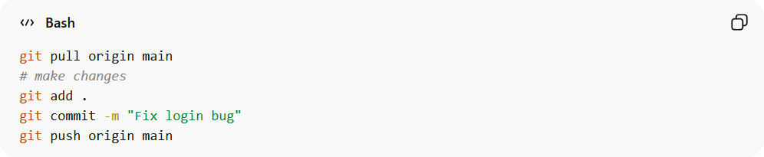
git pull origin main
# make changes
git add .
git commit -m "Fix login bug"
git push origin main

There are:
- No separate feature branches
- No structured branch hierarchy
All work happens on the same branch.

Conceptual Visualization
# Source: AI Source: Provided by: [Data Path: Persons Table -> ID Column: 1, Name_En Column: Motasem Essam] -> From: [ChatGPT] on [2/15/2026]
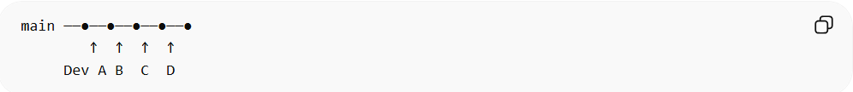
main ──●──●──●──●──●
↑ ↑ ↑ ↑
Dev A B C D
All developers contribute to the same line of history.

When It Is Used
# Source: AI Source: Provided by: [Data Path: Persons Table -> ID Column: 1, Name_En Column: Motasem Essam] -> From: [ChatGPT] on [2/15/2026]
- Small teams
- Academic projects
- Simple applications
- Internal tools
- Environments without strict review processes

Advantages
# Source: AI Source: Provided by: [Data Path: Persons Table -> ID Column: 1, Name_En Column: Motasem Essam] -> From: [ChatGPT] on [2/15/2026]
- Very simple workflow
- Easy to understand
- Minimal branch management
- Fast for small teams

Disadvantages
# Source: AI Source: Provided by: [Data Path: Persons Table -> ID Column: 1, Name_En Column: Motasem Essam] -> From: [ChatGPT] on [2/15/2026]
- Higher risk of merge conflicts
- Production branch may break easily
- Not ideal for large teams
- No isolation for unfinished features

Key Idea (Exam Summary)
# Source: AI Source: Provided by: [Data Path: Persons Table -> ID Column: 1, Name_En Column: Motasem Essam] -> From: [ChatGPT] on [2/15/2026]
Centralized Workflow = Everyone works directly on the main branch in one central repository.
It is the simplest collaboration model in Version Control Systems, but it does not scale efficiently for complex or large projects.

